# The HIGHWIND Experimental Setup

The HIGHWIND Carousel consists of a rotating arm. A model sailplane is flown from the end of the arm. The flight trajectory initially consists of circles flown near the ground, but transitions to kite-like flight as the tether is reeled out.

**Specifications:**

Height of Carousel: 4m

Length of Carousel Arm from center of the carousel : 3 m

Carousel Electrical Requirements: 240V 3 phase grid connection, 30 A maximum (7.2 kW peak power drawn from grid)

Length of Tether: 1-100 m

Weight of Airplane: 5-20 kg (our current plane weighs in at around 8 kg)

Wingspan of Airplane: 1-6m (our current plane has a wingspan of 2.5 m)  
  
The tether consists of a non-conductive dyneema sleeve, with two insulated copper conductors inside.

Diameter of tether: 1-10 mm (currently 3mm)

Strength of the tether: 1-10 kN (currently 5 kN, load tested by us)

Time to land: Average 10 s, worst case 1 minute.  
Time to remove equipment from flying field: 2 hours

We do not plan to do experiments in the dark. While the system itself doesn't depend on ambient light, it is extremely important that we have multiple cameras running during all experiments to help us learn what went wrong in our crashes.  
  
Noise: Comparable to a car traveling at 50 km/hr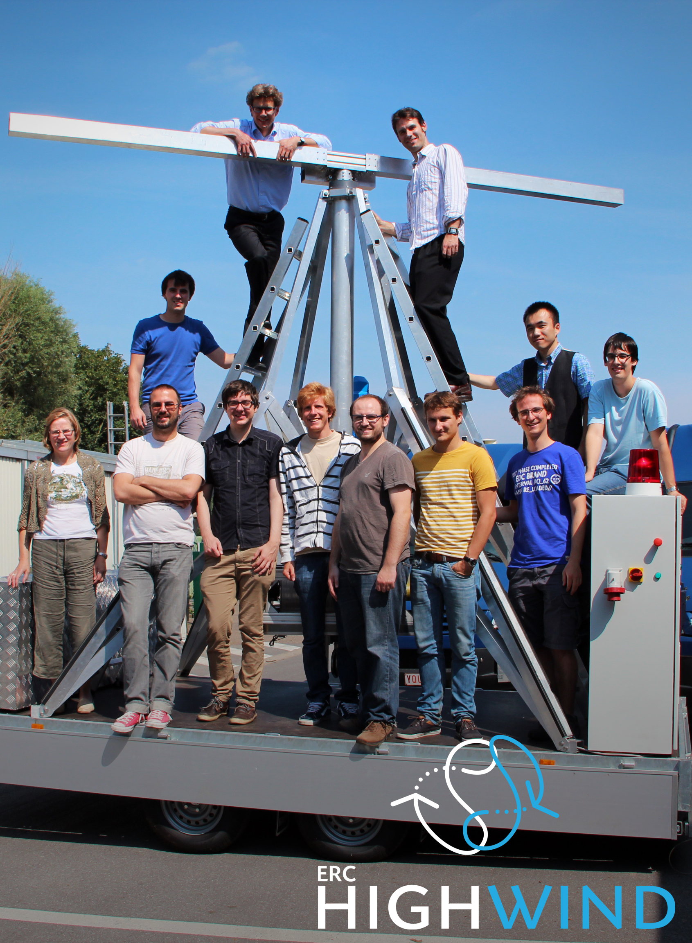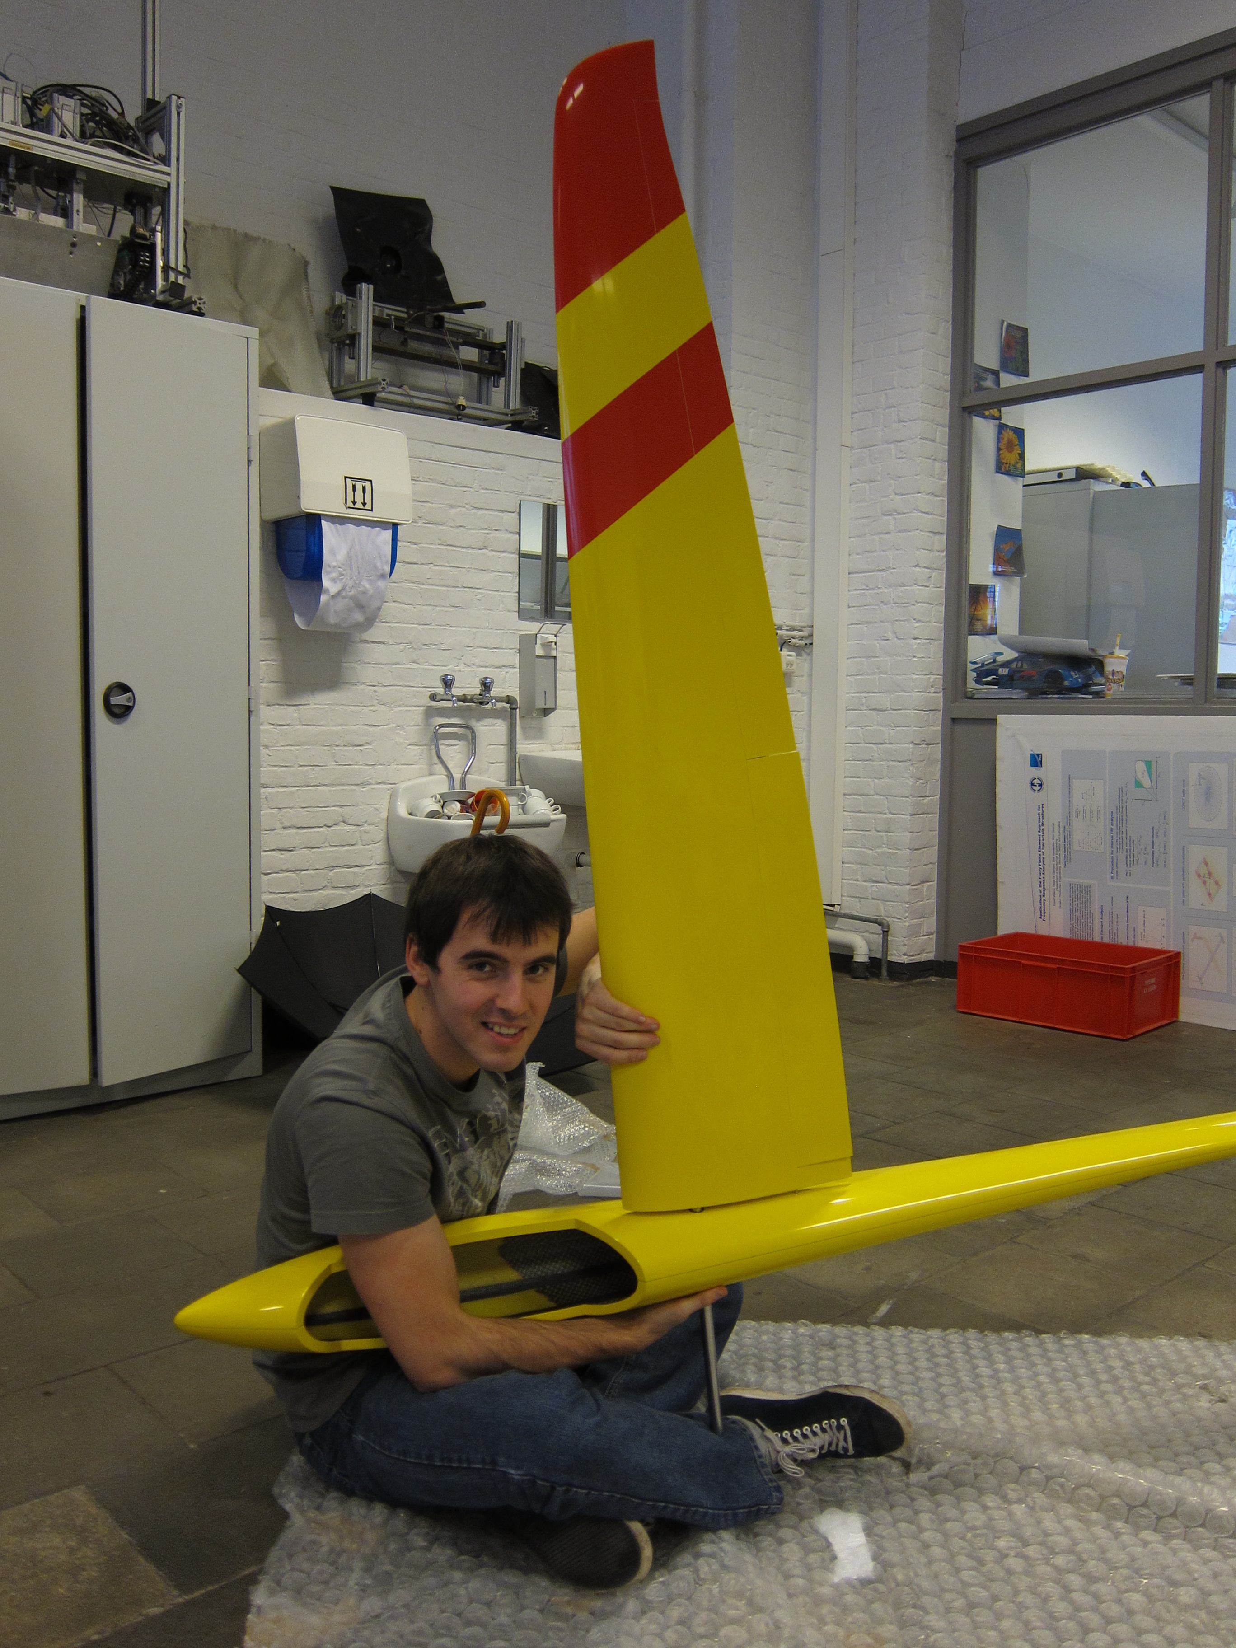

Emmissions: None (No internal combustion engine)